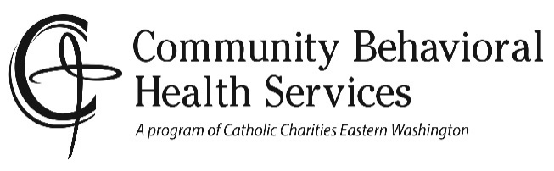
Client copy
Social Media Policy

Community Behavioral Health Services is committed to using social media in a way that can benefit clients without violating ethical, confidentiality, and privacy standards. While social media has enormous potential to provide help to people, it is important that you are aware of potential risks when using online and technology-based communications in a counseling or behavioral health setting.

This information will outline how our counselors and staff will engage with you using social media formats should you choose to use these forms of communication. We encourage you to ask questions about this policy. We will inform you of any changes to this policy as new technology develops and social media changes.

Social Media Platforms:

Your Counselor or Counseling staff may have a Facebook page for his or her professional practice. This page is for professional use only and adding clients as friends or contacts on these sites-can compromise your confidentiality and privacy. Therefore, no friend or contact requests will be accepted from current or former clients on any other social networking site. This also holds true for any of our counselor's or staff’s personal Facebook page or other social networking site. They are not allowed to accept or request friends or contacts from current or former clients on their Facebook page/other social networking site or your Facebook page/or other social networking site.

Counselors and Counseling Staff are prohibited from viewing clients' online content outside of the therapy session and from following former or current clients on blogs or Twitter. If there are things from your online life you wish to share with your counselor, please bring them into your session where you and your counselor can view and explore them together.

Email:

All Community Behavioral Health Service Counselors and Staff have an email address you may use to contact them. While these addresses are password protected, they are not absolutely confidential. We prefer this form of communication be limited to arrange and modify appointments or general comments or questions. Please make sure your message is limited to non-identifying information. For your protection we will not discuss critical issues or client identifying information other than what is required to send and receive such messages. Be aware that our email messages may identify as originating from Catholic Charities Counseling Program. All email correspondence becomes a part of your client record.

SMS (mobile phone text messaging):

At this time, our main telephone system does not accommodate text messaging, however some clinicians carry cell phones. They will inform you of days/hours they may be reached on these phones. Be aware text messaging has no guarantee of privacy and we urge you to only confirm or schedule appointments through this medium. Clinicians will not respond to any personal/clinical information you text, nor initiate any personal/clinical correspondence through text messaging. All text messages will be included in the clinical file.

Use of Search Engines:

Community Behavioral Health Service staff is not allowed to search for clients on Google, Facebook, or other search engines unless there is a specific reason for the search, and it is done with your permission and in your presence.

Business Review Sites:

You may find our professional practice on sites such as Google, Yahoo, Merchant Circle, or other places which list businesses. Many of these sites automatically add listings without the business' knowledge. If you should find a listing for Community Behavioral Health Services, please understand that this listing is not a request for a testimonial, rating, or endorsement from you as a client of our agency. You have the right to express yourself on any site you wish but please remember that in doing so you are self-disclosing as a client. We encourage you to protect your privacy similarly to how our agency protects your confidentiality.

Location-Based Services:

If you use location-based services on your mobile phone please remember there are privacy issues related to using these devices. If you have GPS tracking enabled on your phone/device, it is possible for others to determine that you are in therapy due to regular appointments at our offices.

