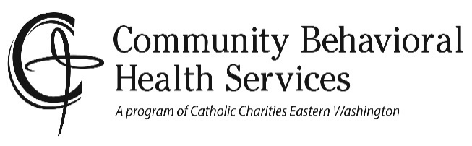
Financial Agreement

I, ________________________________________ hereby consent to receive Behavioral Health services from Community Behavioral Health Services (CBHS), formerly Catholic Charities Counseling Program, a state approved agency designed to provide outpatient behavioral health treatment.

MCO/Insurance Card: I agree to present my card at my scheduled appointments. I understand that by using my Managed Care Organization benefits (Molina, CHPW, or Amerigroup), I authorize CBHS to bill for the services I receive, and there will be no cost to me. I also understand that if my coverage expires I will no longer be eligible for services until such time as it is reinstated. ______ Initials

Fee for Services: I will be responsible for paying $_______ per session as determined by the CBHS sliding fee schedule and my conversation with the Intake Coordinator. If my financial situation changes I will contact Consumer Care Coordinator at 242-2308 to adjust my fee. I understand that I will be billed for any no-show/late cancel appointments.
Phone calls over 15 minutes, court testimony (includes travel), and report writing will be paid at a prorated flat fee of $125.00/hour and I will be informed of these extra charges prior to receiving these services.
My monthly household income before taxes is $ __________ per month and _____ people are dependent on that income. I understand and agree that payment for my treatment will be fulfilled as indicated by my initials.
______ Initials

Private Medical Insurance: I understand that my coverage may pay all or part of my fee and that I am responsible for paying any amount not covered by insurance, including but not limited to deductibles and co-pay amounts. I will pay for services until such a time as coverage is determined.
- I will provide a proper insurance document to the billing office. I understand that different services have different fees. I understand that CBHS bills private medical insurance as a courtesy and that I am responsible to know what my coverage is. I hereby assign benefits for direct payment to CBHS. I hereby authorize CBHS to release required information to my insurance company for billing purposes.
- I understand that I will be billed for any no-show/late cancel appointments. Phone calls over 15 minutes, court testimony, and report writing will be paid at a prorated flat fee of $125.00/hour and I will be informed of these extra charges prior to receiving these services. These fees cannot be paid by my insurance company. ______ Initials

I hereby authorize payment directly to Community Behavioral Health Services of insurance benefits otherwise payable to me. I understand that co-pays are due at time of service. Service charges may accrue if payment is not made in full within 30 days of date of service.

_____________________________________________________ ________________________________
Print Client Name Date

____________________________________________________ ________________________________
Signature of Client or Responsible Party Relationship to Client

_____________________________________________________ ________________________________
Agency Witness Client ID Number

