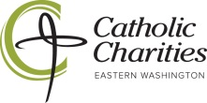
Client copy

Physician Referral List for Medicaid

- Rockwood Clinic 509-838-2531
- CHAS Clinic 509-444-8200 (Also provides dental care)
- Providence Health Care 509-252-9602
- Unify Community Health 509-326-4343 (Also provides dental care)
- Kaiser Permanente (Molina only) 509-688-6700
- Spokane Teaching Health Clinic 509-626-9900

Problem Gambling Resources:
New Horizon Care Centers
701 E 3rd Avenue
Spokane, WA 99202

